Attribute | Studyday | Sample Size | Treatment | Grouping* | Adjusted  Mean | Change in  Adjusted Mean | Change from Baseline P-Value | Standard Error | Geometric Mean | % Change  From  Baseline | % Change - SE From Baseline | % Change + SE From Baseline
Log IL1ra:IL1a Ratio | Baseline | 63 | [D] IT | a | 0.216 | 0.000 | . | 0.078 | 1.64 | 0.00 | 0.00 | 0.00
 |  | 197 | [B] BC-171 BSOG Wacker | a | 0.228 | 0.000 | . | 0.044 | 1.69 | 0.00 | 0.00 | 0.00
 |  | 206 | [C] BC-178 | a | 0.232 | 0.000 | . | 0.043 | 1.71 | 0.00 | 0.00 | 0.00
 |  | 203 | [A] BC-171 Aqua D | a | 0.276 | 0.000 | . | 0.043 | 1.89 | 0.00 | 0.00 | 0.00
Log IL1ra:IL1a Ratio | Week 1 | 59 | [D] IT | a | -0.023 | -0.241 | <.0001 | 0.039 | 0.95 | -42.6 | -47.6 | -37.3
 |  | 203 | [C] BC-178 | b | 0.144 | -0.074 | 0.0005 | 0.021 | 1.39 | -15.7 | -19.7 | -11.5
 |  | 194 | [B] BC-171 BSOG Wacker | b | 0.151 | -0.067 | 0.0020 | 0.021 | 1.42 | -14.2 | -18.4 | -9.89
 |  | 199 | [A] BC-171 Aqua D | b | 0.161 | -0.057 | 0.0071 | 0.021 | 1.45 | -12.4 | -16.6 | -7.98
Log IL1ra:IL1a Ratio | Week 2 | 59 | [D] IT | a | -0.279 | -0.495 | <.0001 | 0.047 | 0.53 | -68.0 | -71.3 | -64.4
 |  | 195 | [C] BC-178 | b | 0.006 | -0.210 | <.0001 | 0.026 | 1.01 | -38.4 | -41.9 | -34.6
 |  | 192 | [B] BC-171 BSOG Wacker | b | 0.013 | -0.203 | <.0001 | 0.026 | 1.03 | -37.4 | -41.0 | -33.5
 |  | 197 | [A] BC-171 Aqua D | c | 0.066 | -0.150 | <.0001 | 0.026 | 1.16 | -29.3 | -33.3 | -25.0
Log IL1ra:IL1a Ratio | Week 3 | 57 | [D] IT | a | -0.309 | -0.523 | <.0001 | 0.048 | 0.49 | -70.0 | -73.2 | -66.4
 |  | 190 | [B] BC-171 BSOG Wacker | b | -0.084 | -0.298 | <.0001 | 0.027 | 0.82 | -49.7 | -52.7 | -46.5
 |  | 197 | [C] BC-178 | b | -0.067 | -0.281 | <.0001 | 0.026 | 0.86 | -47.6 | -50.7 | -44.4
 |  | 197 | [A] BC-171 Aqua D | b | -0.046 | -0.259 | <.0001 | 0.026 | 0.90 | -45.0 | -48.2 | -41.6

P-Values for Treatment Mean Pairwise Comparisons
Studyday | Treatment | [A] BC-171 Aqua D | [B] BC-171 BSOG Wacker | [C] BC-178 | [D] IT | Treatment Code Key
Baseline | [A] BC-171 Aqua D | ------ | 0.4399 | 0.4769 | 0.5043 | [A] BC-171 Aqua D
 | [B] BC-171 BSOG Wacker | 0.4399 | ------ | 0.9446 | 0.8956 | [B] BC-171 BSOG Wacker
 | [C] BC-178 | 0.4769 | 0.9446 | ------ | 0.8571 | [C] BC-178
 | [D] IT | 0.5043 | 0.8956 | 0.8571 | ------ | [D] IT
Week 1 | [A] BC-171 Aqua D | ------ | 0.7561 | 0.5766 | <.0001* | [A] BC-171 Aqua D
 | [B] BC-171 BSOG Wacker | 0.7561 | ------ | 0.8083 | <.0001* | [B] BC-171 BSOG Wacker
 | [C] BC-178 | 0.5766 | 0.8083 | ------ | 0.0002* | [C] BC-178
 | [D] IT | <.0001* | <.0001* | 0.0002* | ------ | [D] IT
Week 2 | [A] BC-171 Aqua D | ------ | 0.1476* | 0.0985* | <.0001* | [A] BC-171 Aqua D
 | [B] BC-171 BSOG Wacker | 0.1476* | ------ | 0.8434 | <.0001* | [B] BC-171 BSOG Wacker
 | [C] BC-178 | 0.0985* | 0.8434 | ------ | <.0001* | [C] BC-178
 | [D] IT | <.0001* | <.0001* | <.0001* | ------ | [D] IT
Week 3 | [A] BC-171 Aqua D | ------ | 0.2993 | 0.5650 | <.0001* | [A] BC-171 Aqua D
 | [B] BC-171 BSOG Wacker | 0.2993 | ------ | 0.6393 | <.0001* | [B] BC-171 BSOG Wacker
 | [C] BC-178 | 0.5650 | 0.6393 | ------ | <.0001* | [C] BC-178
 | [D] IT | <.0001* | <.0001* | <.0001* | ------ | [D] IT
A p-value with a '*' indicates a significant difference between treatments (P<=0.2).

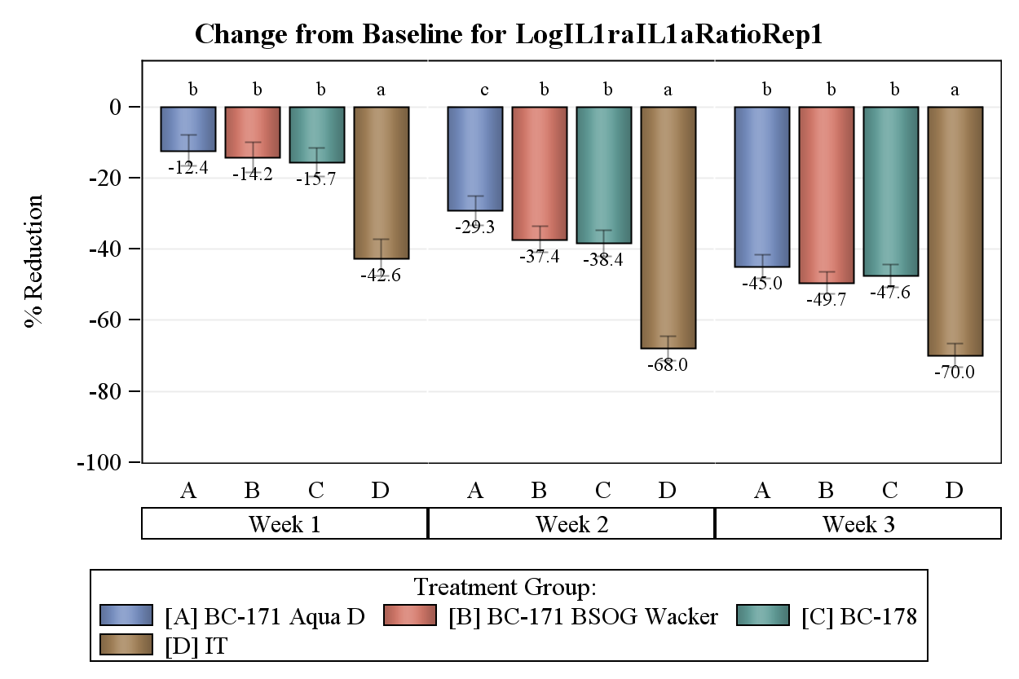
Attribute | Studyday | Sample Size | Treatment | Grouping* | Adjusted  Mean | Change in  Adjusted Mean | Change from Baseline P-Value | Standard Error | Geometric Mean | % Change  From  Baseline | % Change - SE From Baseline | % Change + SE From Baseline
Log IL1ra Protein Normalized | Baseline | 197 | [B] BC-171 BSOG Wacker | a | 1.004 | 0.000 | . | 0.026 | 10.08 | 0.00 | 0.00 | 0.00
 |  | 203 | [A] BC-171 Aqua D | a | 1.028 | 0.000 | . | 0.025 | 10.66 | 0.00 | 0.00 | 0.00
 |  | 63 | [D] IT | a | 1.029 | 0.000 | . | 0.046 | 10.70 | 0.00 | 0.00 | 0.00
 |  | 206 | [C] BC-178 | a | 1.043 | 0.000 | . | 0.025 | 11.05 | 0.00 | 0.00 | 0.00
Log IL1ra Protein Normalized | Week 1 | 59 | [D] IT | a | 0.787 | -0.223 | <.0001 | 0.029 | 6.12 | -40.2 | -44.0 | -36.0
 |  | 203 | [C] BC-178 | b | 0.985 | -0.025 | 0.1141 | 0.016 | 9.67 | -5.53 | -8.87 | -2.07
 |  | 199 | [A] BC-171 Aqua D | b | 0.987 | -0.023 | 0.1443 | 0.016 | 9.70 | -5.16 | -8.53 | -1.66
 |  | 194 | [B] BC-171 BSOG Wacker | b | 1.001 | -0.009 | 0.5613 | 0.016 | 10.02 | -2.11 | -5.63 | 1.55
Log IL1ra Protein Normalized | Week 2 | 59 | [D] IT | a | 0.539 | -0.469 | <.0001 | 0.037 | 3.46 | -66.0 | -68.8 | -63.0
 |  | 195 | [C] BC-178 | b | 0.868 | -0.140 | <.0001 | 0.020 | 7.38 | -27.6 | -30.9 | -24.1
 |  | 192 | [B] BC-171 BSOG Wacker | b | 0.884 | -0.124 | <.0001 | 0.021 | 7.66 | -24.8 | -28.3 | -21.2
 |  | 197 | [A] BC-171 Aqua D | b | 0.901 | -0.107 | <.0001 | 0.020 | 7.96 | -21.9 | -25.5 | -18.2
Log IL1ra Protein Normalized | Week 3 | 57 | [D] IT | a | 0.461 | -0.546 | <.0001 | 0.040 | 2.89 | -71.5 | -74.0 | -68.8
 |  | 190 | [B] BC-171 BSOG Wacker | b | 0.783 | -0.224 | <.0001 | 0.022 | 6.07 | -40.3 | -43.2 | -37.2
 |  | 197 | [A] BC-171 Aqua D | b | 0.801 | -0.206 | <.0001 | 0.021 | 6.33 | -37.7 | -40.7 | -34.6
 |  | 197 | [C] BC-178 | b | 0.804 | -0.203 | <.0001 | 0.021 | 6.36 | -37.4 | -40.4 | -34.2

P-Values for Treatment Mean Pairwise Comparisons
Studyday | Treatment | [A] BC-171 Aqua D | [B] BC-171 BSOG Wacker | [C] BC-178 | [D] IT | Treatment Code Key
Baseline | [A] BC-171 Aqua D | ------ | 0.5008 | 0.6654 | 0.9794 | [A] BC-171 Aqua D
 | [B] BC-171 BSOG Wacker | 0.5008 | ------ | 0.2692 | 0.6235 | [B] BC-171 BSOG Wacker
 | [C] BC-178 | 0.6654 | 0.2692 | ------ | 0.7862 | [C] BC-178
 | [D] IT | 0.9794 | 0.6235 | 0.7862 | ------ | [D] IT
Week 1 | [A] BC-171 Aqua D | ------ | 0.5393 | 0.9374 | <.0001* | [A] BC-171 Aqua D
 | [B] BC-171 BSOG Wacker | 0.5393 | ------ | 0.4873 | <.0001* | [B] BC-171 BSOG Wacker
 | [C] BC-178 | 0.9374 | 0.4873 | ------ | <.0001* | [C] BC-178
 | [D] IT | <.0001* | <.0001* | <.0001* | ------ | [D] IT
Week 2 | [A] BC-171 Aqua D | ------ | 0.5682 | 0.2491 | <.0001* | [A] BC-171 Aqua D
 | [B] BC-171 BSOG Wacker | 0.5682 | ------ | 0.5649 | <.0001* | [B] BC-171 BSOG Wacker
 | [C] BC-178 | 0.2491 | 0.5649 | ------ | <.0001* | [C] BC-178
 | [D] IT | <.0001* | <.0001* | <.0001* | ------ | [D] IT
Week 3 | [A] BC-171 Aqua D | ------ | 0.5505 | 0.9393 | <.0001* | [A] BC-171 Aqua D
 | [B] BC-171 BSOG Wacker | 0.5505 | ------ | 0.5013 | <.0001* | [B] BC-171 BSOG Wacker
 | [C] BC-178 | 0.9393 | 0.5013 | ------ | <.0001* | [C] BC-178
 | [D] IT | <.0001* | <.0001* | <.0001* | ------ | [D] IT
A p-value with a '*' indicates a significant difference between treatments (P<=0.2).

